**JSPM’s**

**Imperial College Of Engineering & Research ,Wagholi**

**DEPARTMENT OF COMPUTER ENGINEERING**

**CLASS-B.E. COMPUTER**

**Smart System Design and Analysis**

**Question Bank**

1. Write and explain A* Algorithm
2. Explain AO* algorithm with example.
3. Explain a learning agent architecture and explain its components.
4. Define search proble.Solve 8 queens problem as a state space search problem.
5. Explain- A* is optimally efficient and complete.
6. Explain the main factors of designing intelligent agent with example.
7. Explain MINI-Max search algorithm for solving any game.
8. Explain in detail what do you understand by task environment.
9. Develop a PEAS description of task environment for each of the following agent

A]Satellite Image analysis system

B] Interactive English Tutor

10.Give the initial state, goal state ,successor function and cost function for the following and solve

Following problem using Hill Climbing algorithm

“You are given three jugs: 12 litres,8 litres,3 litrs and water tap.You can fill the jugs and empty

Them fro one to another or on ground. The goal is to measure exactly 1 liter water.

1. Give the initial state, goal state ,successor function and cost function for the following and

Solve Following problem using A* algorithm

“You are given three jugs: 12 litres,8 litres,3 liters and water tap. You can fill the jugs and empty

Them fro one to another or on ground. The goal is to measure exactly 1 litre water.

11.What is alpha –beata cut off.Explain the concept with the help of following game tree.

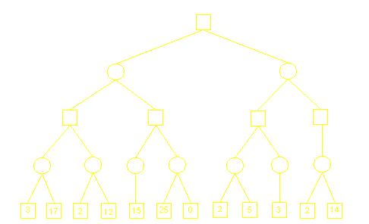

12.For each of the following agents develop a PEAS description of the task environment

i)              Robot soccer player.

ii)           Internet book-shopping agent.

13.What is heuristic search? Explain with example. Also write heuristics function for following problems.

i)  Travelling Salesman Problem.

       ii) Tic-tac toe.

14. What is uninformed (or blind) search and how does it differ from informed (or heuristic) search?

15. Write short note on:

i) Simulated Annealing

ii) Genetic algorithms.

16. Explain intelligence and artificial intelligence system

17. Define Artificial Intelligence? Give any five applications of AI.

18. What is an Intelligent Agent? Give a typical structure of an Intelligent Agent

19. Give a state space approach to solve the following problem,   
"Three cannibals and three missionaries are standing on west bank of the river. A boat is available that will hold either one or two people. If the missionaries are ever outnumbered - on either bank of the river the cannibals will eat them. Design a sequence to get everyone to the east bank of the river".

20. What is Hill Climbing? Explain in detail the phenomenon of Local Maxima, Plateau and Ridge.

21.Explain AND-OR graphs with example.

22.Explain problem reduction method of searching in AI

23.For each of the following agents develop a PEAS description of the task environment

i)              Vacuum Cleaner

ii)           Chess player

24.Describe the problem formulation steps with example.

25. Describe how search techniques are useful for finding solution to the problem

26. What is problem solving agent?

27. Distinguish between DFS & BFS also explain the technique to overcome the drawback form both

28. Discuss the time and space complexities of the uniformed search technique

29. What is greedy also explain greedy algorithm with example

30. Explain the A* and AO* algorithm with example

31. What is adversarial search method explain mini-max algorithm

32. What is Constraint Satisfaction Problem, also explain CSP search problem

33. Explain different Heuristic Functions in detail